**Excel Assignment - 7**

*1. Using Insert Function, give examples of any function available in the diﬀerent dropdowns present in the function library. For example AutoSum, Recently Used, Text, Date & Time, etc.*

Example 1 :

Step 1. Select a cell.

Step 2. Click the Insert Function button. The ‘Insert Function‘ dialog box appears.

Step 3. Look for a function or select a function from a category. For example, Sum of Total salary paid

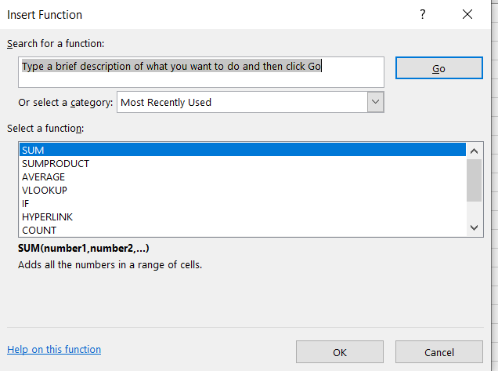

Step.4 Click OK. The ‘Function Arguments‘ dialog box appears.

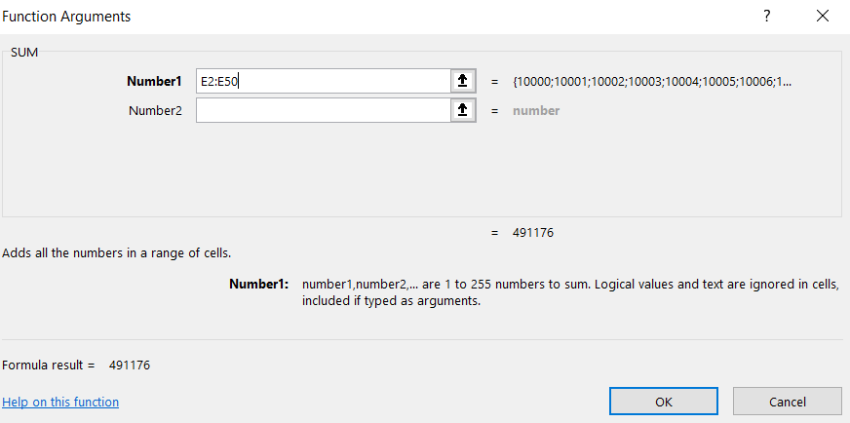

Step 5. Click within the Range box and select the range E2:E50 .

Step 6. Click OK.

Result: Excel will sum all the number which are present from E2:E50.



Example 2 : - To insert MAX function, need to follow the following steps:

Step 1. Select a cell.

Step 2. Click the Insert Function button. The ‘Insert Function‘ dialog box appears.

Step 3. Look for a function or select a function from a category. For example, choose MAX from the statistical category.

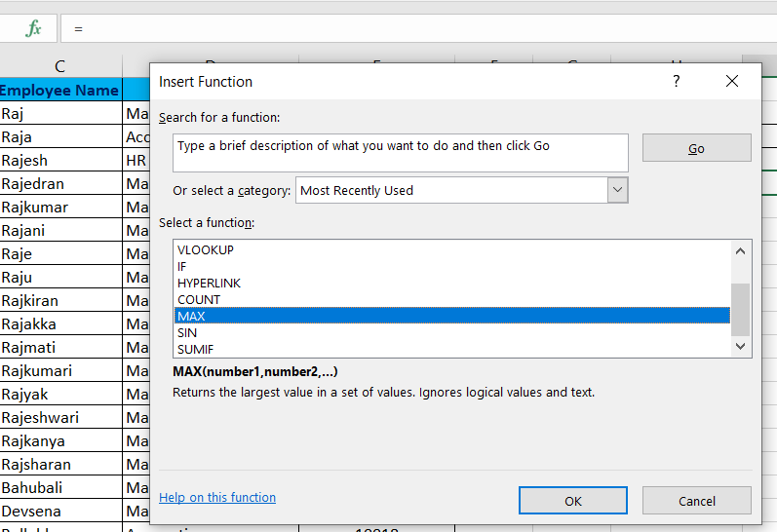

Step 4. Click OK. The ‘Function Arguments‘ dialog box appears.

Step 5. Click within the Range box and select the range E2:E50.

Step 6. Click OK

Result: Excel will MAX all the number which are present from E2:E50.

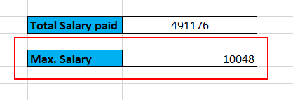

*2. What are the diﬀerent ways you can select columns and rows?*

**Select one or more rows and columns**

1. Select the letter at the top to select the entire column. Or click on any cell in the column and then press Ctrl + Space.
2. Select the row number to select the entire row. Or click on any cell in the row and then press Shift + Space.
3. To select non-adjacent rows or columns, hold Ctrl and select the row or column numbers.

Rows can have a maximum height of 409 points, with 1 point equal to approximately 1/72 inch or 0.035 cm. The default height of an Excel row varies from 15 points on a 100% dpi to 14.3 points on a 200% dpi.

When a column width or row height is set to 0, such column/row is not visible on a sheet (hidden).

*3. What is AutoFit and why do we use it?*

Excel's AutoFit feature is designed to automatically resize cells in a worksheet to accommodate different sized data without having to manually change the column width and row height.

i) AutoFit Row Height - adjusts the column width to match the largest value in the row. This option expands the row vertically to hold multi-line or extra-tall text.

ii) Unlike column width, Microsoft Excel changes the row height automatically based on the height of the text you type in a cell, therefore you won't really need to auto fit rows as often as columns. However, when exporting or copying data from another source, row heights may not auto adjust, and in these situations the AutoFit Row Height opting comes in helpful.

iii) When resizing cells in Excel, either automatically or manually, please bear in mind the following limits to how big columns and rows can be made.

iv) Columns can have a maximum width of 255, which is the maximum number of characters in the standard font size that a column can hold. Using a bigger font size or applying additional font characteristics such as italics or bold may significantly reduce the maximum column width. The default size of columns in Excel is 8.43.

v) Rows can have a maximum height of 409 points, with 1 point equal to approximately 1/72 inch or 0.035 cm. The default height of an Excel row varies from 15 points on a 100% dpi to 14.3 points on a 200% dpi.

When a column width or row height is set to 0, such column/row is not visible on a sheet (hidden).

*4. How can you insert new rows and columns into the existing table?*

First, let’s consider the methods of inserting sheet rows into table :-

1. Click on any row or cell in row of a table above of which row to be inserted.

2. Right click and select the inert.

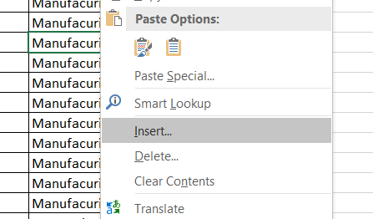

3. If you select row, one row will be added to the slected row. If you select the cell, Below screen will open . Select the entire row option.

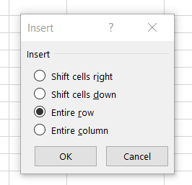

4. This will add the row above the selected cell.

5. Keyboard shortcut is “Ctrl+plus sign (+)”

let’s consider the methods of inserting columns :-

1. Click on any column or cell in column of a table left side of which column to be inserted.

2. Right click and select the inert.

3. . If you select column, one column will be added to the left side of selected column. If you select the cell ,Below screen will open . Select the entire column.

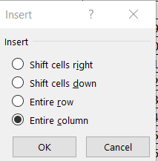

4. This will add the column to the left side of selected cell.

5. Keyboard shortcut is “Ctrl+plus sign (+)”

*5. How do you hide and unhide columns in excel?*

Hide columns

1. Select one or more columns, and then press Ctrl to select additional columns that aren't adjacent.
2. Right-click the selected columns, and then select Hide.

Unhide columns

1. Select the adjacent columns for the hidden columns.
2. Right-click the selected columns, and then select Unhide.Or double-click the double line between the two columns where hidden columns exist.

*6. Create an appropriate table within the worksheet and use diﬀerent functions available in the AutoSum command.*

1. SUM function :

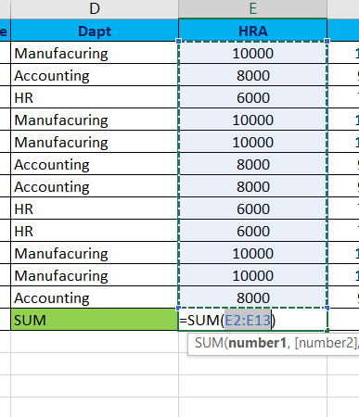

2. Average function :

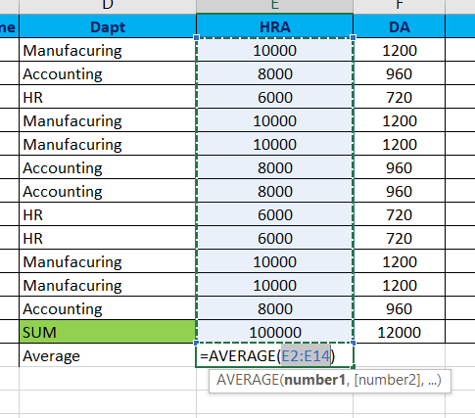

**3. Count number function :-**

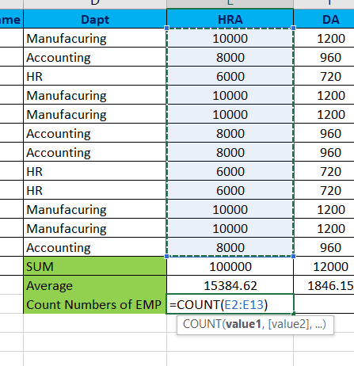

**4. MAX function :-**

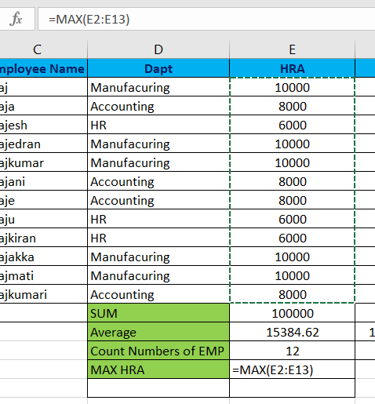

**5. MIN function :-**

